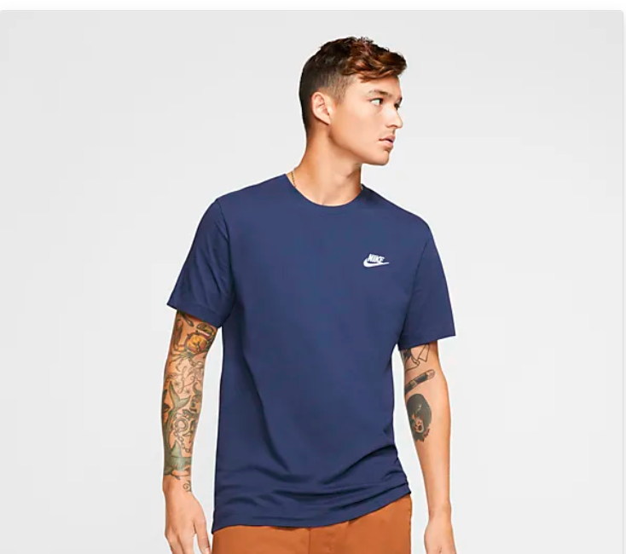

Nike Sportswear Premium Essentials

Good t-shirt designs are those that people want to wear. Make sure your t-shirt doesn’t get stuffed in the back of the closet with a custom quote t-shirt designed just for you by a professional designer. Need ideas? We’ve collected some amazing examples of quote t-shirts created by our global community of designers. Get inspired and start planning your custom quote [t-shirt design](https://99designs.com/t-shirt-design) today.